Should juveniles be tried as adults in the criminal justice system?

By

A project submitted to the faculty of the Graduate School of Public Service at the University of Houston-Downtown in fulfillment of requirements for the degree of Master of Criminal Justice

Date

_______________________________________
Dean’s Name, Dean College of Public Service
Executive Summary
In adult courts, various matters arise, especially when juveniles are tried within these courts. Such issues happen since United States criminal justice system has failed to come up with effective ways to deal with juvenile offenders. It is unconstitutional to try offending juveniles in adult courts How the brain develops among adolescents explains why juvenile offenders should not be tried in an adult court. Reports show that one's brain fully develops at the age of twenty-one. Serving sentences in adult jails makes it hard for juvenile offenders to reform and reintegrate into the community.
Trying and prosecuting juvenile offenders in juvenile courts exposes the offenders to beneficial counseling programs. During the counseling programs, the offenders are exposed to behavior therapy, supervision, and training to help them minimize offenses. Hence, juvenile offenders who are tried in adult court misses such chances, and eventually, they are exposed to dangerous treatment from adult inmates such as sexual, psychological, and physical abuse. Juvenile offenders who engaged in violent crimes are placed in rehabilitation programs. The process focuses on cognitive behavioral therapy intervention. Once the rehabilitation is over, the offenders become productive members of the community due to the prosocial activities offered in the rehabilitation.
The effectiveness of trying juveniles in an adult court is questionable because juvenile offenders require more interventions like educational and counseling programs to improve their behaviors. Convicting juvenile offenders in an adult court undermines the sole purpose of rehabilitation programs offer, which is not punishment. Excluding family members of the adolescent offender is mentally and emotionally tormenting since they are not given chance to determine what will take place, especially when the adolescents are found guilty. Hence trying and convicting juvenile offenders in an adult court is an ineffective and costly method of preventing offenses committed by adolescents.
Introduction
In the US, the adult court system has turned out to be a place for violent juveniles. The Juvenile Justice System was developed to provide rehabilitation services for offenders who commit minor crimes like vandalism, shoplifting, and truancy. However, it is controversial whether it is suitable for juveniles to be tried as adults in the criminal justice system. The issue of juveniles being tried as adults dates back years ago. For example, in the case Thompson v. Oklahoma (1988), the Supreme Court argued that there is no valid reason to sentence any person under the age of 16 to the death penalty. According to Supreme Court rulings, juveniles cannot act with a degree of culpability to justify their ultimate penalty. There are several opinions to address the issue of juveniles, such as differing laws and statutes from different states. For example, between 1992 and 1999, forty-nine states amended juvenile laws where juveniles committing violent crimes were to be tried in adult courts.
Why should offender juveniles be tried and treated as adults?
Several issues happen when juveniles are tried in adult courts. The US criminal justice system has not y correctly figured how to deal with offending juveniles. Treating and trying juveniles in adult courts system is unconstitutional. The constitution in the fourth, fifth, and eighth amendment describes liberty, life, and, property rights (Graber, 2019). Therefore, legislation providing prosecutors powers to decide how to try juveniles as an adult is unconstitutional. The eighth amendment also states that "Excessive bails are unnecessary nor excessive fines and unusual punishment inflicted on offenders. Therefore, the eighth amendment demonstrates that extreme fines and bail are unacceptable besides unusual and cruel punishment. In Roper v Simons's case rulings, the judges argued that the eighth and fourteenth amendment prohibits the death penalty among juvenile offenders under 18 years. In 2010, the Supreme Court declared that juvenile offenders should not receive life sentences without parole sentences if the crimes committed are not homicides. When juveniles are tried and treated in adult courts, their constitutional rights are abused. Constitutional freedoms and rights like Miranda require special consideration when applied to teenage offenders.
Adolescent brain development is another reason why juveniles should not be tried in adult courts. An individual brain is not completely developed until the age of twenty-one. This causes dilemma when courts decide to treat juveniles as an adult (Graber, 2019). Notably, the brains of juveniles are different from that of adults in making decisions. Controlling impulsivity and solving problems are considered as the last parts of brain development. Studies on brain development indicate that the frontal lobe starts to develop at the age of 20 (Graber, 2019). The frontal lobe is part of the brain that helps in anticipating consequences, controlling impulses, thinking, and planning. According to Bonnie & Scott (2013), Miller v Alabama (2012), and Graham v. Florida (2010), cases reveals brain science while striking down life sentences for juveniles. The case of Miller and Alabama demonstrates significant differences between juveniles and adults in behavior control. According to Steinberg Laurence, an expert in the study of juvenile brains, teens' brains are like car with an excellent accelerator but with a weak brake (Baruwa, 2013). Therefore, with strong impulses of poor control can result into a crash. This statement indicates that juveniles should not be either tried or treated as adults in the criminal justice system.
Although juveniles may commit adult crimes, juveniles' mental and maturity levels should change the consequences and nature of the crime. Therefore, holding juveniles to similar standards as adults in their actions and thinking is improbable and unscientific. According to Powers (2009), judges should consider physiological maturation, culpability, and impulse control and not necessarily age difference when treating juveniles as adults in the courts' system. Juveniles, particularly first-time offenders, have little understanding of the law process and their rights as citizens. A study by Grisso (2003) demonstrates that juveniles cannot make informed decisions due to their choice.
When Juveniles are tried in the adult court system, there are several juvenile rehabilitation problems. When juveniles are placed in adult jails for long, they are unable to reform for purposes of reintegrating into society. Juveniles are impressionable and susceptible, and thus being treated as adults is both harmful and unproductive. Based on US laws, minors should be separated from adults. However, juveniles tried in criminal courts are parted. This makes them susceptible to adult offenders and learns criminal instincts. Additionally, most prison facility does not train their officers on how to handle and accommodate juvenile offenders. Juveniles placed in the adult criminal system are more likely to be rearrested. The juvenile system accentuates rehabilitation education and treatment for young offenders. Notably, juvenile offenders are likely to succeed and change their behaviors if they receive services that support positive development.
Treating juvenile offenders in an adult's criminal system makes them vulnerable to criminal activities and does not reduce recidivism. The main reason juveniles are tried like adults is to face harsh punishments to prevent future criminal behaviors. Nonetheless, a report from California University School of the law reveals that there is minimal or no deterrence when juveniles are prosecuted as adults. The reports indicate that 82% of juveniles released were later arrested (Scialabba, 2016). Young people are immature, irrational and need parental figures to direct and guide them towards developing positive behaviors. However, when juveniles are incarcerated with adult criminals, they become prone to negative influences. While in prison, several negative experiences like rape, assault, and harassment make them adopt similar behavior in the future. According to Castro, Muhammad & Arthur (2012), while tried in adult prisons, juveniles lack rehabilitative forms of education, counseling, and training. Trying and treating juveniles in adult court is mandatory sentencing. In the US, every state has regulations regarding mandatory sentencing on particular crimes and trying juveniles as adults.
In society, persons under the age of 18 are prohibited from range of activities like drinking, gambling, smoking, and married which are allowed for adults. Therefore, it is wrong for the criminal justice system to try and treat juveniles as adults. According to Baruwa (2013), law enforcement in the US arrests approximately 2.2 million juveniles every year, and 1.7 million cases are referred to juvenile court while 200,000 children are tried as adults. Most of the youths tried in adult courts commit non-person crimes (Appendix 2). The Blacks and the Hispanics lead in the number of youths arrested annually by the law enforcers. The pie chart below reveals the total of juvenile arrests in Crosstown (Los Angeles) in 2019.

The adult trial system is different from the juvenile system. For example, it does not take into considerations maturity levels and development of juvenile offenders. Juveniles should not be tried as adults, and thus, it is significant to maintain an effective juvenile justice system.
In all 50 states in the US, teenagers under the age of 18 can be tried in adult courts using various juvenile laws. For example, in California, teens as young as 14 are tried as adults before a juvenile court judge. The practice undermines the creation of the juvenile court system by pursuing punishment and nor rehabilitation. Additionally, this practice conflicts with developmental science. Notably, adult courts usually ignore environmental factors which affect adolescent behaviors (Graber, 2019). For example, when individuals are changed in this court, they are either found innocent or guilty and receive corporal punishment. On the other hand, juvenile courts focus on the behaviors of youth and not just their innocence and guilt. Moreover, judges in juvenile courts can review youth case with family members and the community. In adult courts, parents and other family members are excluded and not given meaningful opportunities to determine what will happen to their children. Notably, failure to participate completely while a close person faces charges is emotionally and mentally harmful to the family.
There is a lack of consistency in the juvenile justice system and fear of violent offenders. The overarching fear among the public and the best way to treat violent juvenile offenders is locking up them like adult criminals. According to Semple (2011), most individuals in society believe that juvenile offenders should be treated as adults. The current juvenile system is unable to handle large number of youth offenders. On average, over 48 000 youths are held in facilities away from home daily. Detention centers lead with an average of 17000 youths daily (Appendix 5).
Additionally, the juvenile system uses a rehabilitative approach that accentuates individual treatment resulting in discretion abuse (Graber, 2019). Although, there have been laws and acts to improve the juvenile justice system in previous years, juveniles committing violent offenses should be tried and treated as adults. Trying and treating juveniles as adults minimizes the chances of committing or repeating violent crimes. It serves as a lesson for other teenagers to abstain from committing similar crimes leading to life and death sentences.
During the 18th century, the US criminal justice system treated juveniles as adults since children older than 14 understood what was wrong and right (Martin, 2021). When crimes happen without considering who commits it affect the lives of many individuals. For example, if a person is killed, close family and friends are negatively impacted. A juvenile committing such murder should have similar results with an adult. On average, 7 346 youths are sentenced to life with parole annually. About 2300 youths are sentenced to life without parole, while about 2000 youths serve virtual life (Appendix 3). While in recent years, several states in the US have changed their laws making it easier to try and treat juveniles as adults. The reason why states are changing their laws is because the juvenile justice system has failed to protect the public from violent crimes committed by teenagers. The problem with the juvenile system is that it was developed to help troubled youth who commits minor offenses, but most of the reported cases involve violent crimes. Therefore, juveniles who commit violent crimes like murder, rape, aggravated assault, and armed robbery should be tried as adults.
The adult criminal justice system provides juveniles with proper jury judgment and good representation. On the other hand, the juvenile system provides no jury, and judges are over-worked besides counseling. Therefore, juveniles tried and treated as adults are likely to be incarcerated compared to those in the juvenile system. An adult criminal system aims at protecting society from dangerous, violent crimes by locking offenders for long periods in prison, thus providing opportunities to reform. Several reasons make the criminal justice system try and treat juveniles as adults: serious offenses, bad records, teens failing to change their behaviors despite rehabilitation efforts. Trying juveniles as adults teaches them accountability and learn how to prevent themselves from engaging in such acts.
In the last fifty years, violent crimes like murder committed by juveniles have raised concerns in the criminal justice system. Notably, decisions by the Supreme Court have reduced the likelihood that juvenile offenders should be sentenced to life without seeking parole. According to Heide (2020), US legislators have passed laws that make it easy to transfer juveniles who commit serious crimes like murder in adult courts to respond to dramatic upswing. The primary aim is to make juvenile offenders who commit serious offenses experience capital punishment, lengthy prison sentences, and life without parole, just like adult counterparts who commit similar crimes. Additionally, there have been several legal challenges to treat juveniles as adults as one way of responding to public demand.
Policymakers in the justice system should acknowledge that adults and juveniles have different needs. Notably, both deserve similar rights in the law process. Additionally, adolescents and adults should have equal opportunities to get rehabilitation services, but this process should be different. Juveniles require more opportunities to reform since the court's responsibility is to guide them and provide rehabilitation services. However, getting support is challenging since the current juvenile offenders are super-predators. According to Graber (2019), there should be changes in rehabilitation programs. Judges should consider a variety of options and programs when juvenile sentencing offenders. Education-based programs are the best alternative for less violent offenders. This program will help juveniles learn how to behave. Moreover, the program will keep juveniles offenders away from detention facilities and look at their daily actions. To effectively rehabilitate every offender according to their specific needs, there should program for all kinds of offenses. This should not only reduce the number of juveniles indention but will prevent other juveniles from committing crimes.
What effect does trying juveniles as adults have in the rehabilitation process of those
Juveniles?
The rehabilitation process for juvenile offenders uses intervention programs like supervision, probation, training, work readiness, behavior therapy, and cognitive skills to change behavior and minimize offenses. Notably, rehabilitation programs are significant for juvenile offenders since they set a good foundation for living a healthy lifestyle. Additionally, rehabilitation is practical because the methods applied aim to address delinquents' personal needs and provide them with realistic options of making it in the community without recidivating. According to Pauzi (2019), the juvenile rehabilitation process involves aspects like virtue inculcation, development of self-discipline, and skills.
Juvenile offenders who are tried in detention centers are less likely to re-offend or recidivate compared to their counterparts in adult courts. This shows that adolescents delinquents have great capabilities of being rehabilitated if treated as juveniles and not adults. Rehabilitation programs for juvenile offenders accentuate counseling and educational opportunities and not punishments which reduce recidivism rates. Violent adolescent criminals treated in juvenile facilities are effectively rehabilitated because of Cognitive behavioral therapy (CBT) interventions programs and education opportunities (Lambie & Randall, 2013). Programs in juvenile facilities focus on prosocial activities and provide long-term positive results, thus allowing offenders to become productive members of society. Juvenile offenders minimize or end their criminal behaviors after learning prosocial behaviors.
When juvenile offenders are tried in adult courts, they lose the opportunities in the rehabilitation process. Juveniles offenders prosecuted and tried in juvenile courts are likely to benefit from resources like counseling programs. Trying juvenile delinquents as adults reveals that proportional punishment disrupts the goal of rehabilitation in the juvenile justice system (Mulvey & Schubert, 2012). Transferring and tying adolescent offenders in adult courts is a weighty decision and presents symbolic meaning to the justice system. Trying juveniles in adult courts makes them vulnerable to harsh punishment like sexual, physical, and psychological victimization by adult inmates (Appendix 6). Males lead in cases of physical assault while females lead in sexual assault, as shown below.
Physical assault |  | Sexual assault
Males | 35% | 10%
Females | 24% | 25%

In 2012, the US Supreme Court stated that life sentencing of juveniles is unconstitutional.
Juvenile offenders experience numerous dangers in adult prisons which negatively affect the rehabilitation process. Juveniles treated in adults prison experience problems of identity formation, growth in competencies and skills, and relationships. According to Hurst (2019), the prison environment usually challenges people's identities and value systems, including adults and violent criminals. Notably, when adolescent offenders are involved in the adult prison system in their stage of discovering values and identities, they are at high risk of maladjustment. The environment in adult prisons does not encourage emotional or physical well-being but promotes criminal and violent activity.
Putting juvenile offenders in a place that is not mentally and physically safe negatively affects the process of developing a healthy value and identity system. Identity development is the process of finding a sense of self during the adolescent period. To become successful in this process, most adolescents discover their values and personalities by interacting with parents and peers to achieve self-identity traits (Hurst, 2019). However, juvenile offenders in adult prisons experience pressures and dangers which prevent healthy identity development. The peers found in prisons are criminals who encourage them to engage in criminal behavior which undermine healthy development. Juveniles in adult rehabilitation facilities attempt to achieve a developmental task in an environment that presents actual dangers towards their safety. The chances of getting positive support for identity formation from adults prisoners or peers are low (Mulvey & Schubert, 2012). Jails and prisons are created to break down identities and not necessarily promoting resilient and new places where adolescents can change their behaviors. Transferring adolescent offenders in adult courts dismisses principles of moral accountability and focus on crime which affects their rehabilitation process. According to Tisdale (2020), due to the ever-changing situation of adolescent self–esteem and identity, the incarceration process in adult prison is associated with long-term impacts on adolescents' sense of self-worth and self. Despite psychological and physical dangers arising from incarceration, adolescents charged in adults prisons experience negative disruption during late adolescence and early adulthood.
Trying and treating juvenile offenders in the adult criminal system exposes them to sexual and rape assault. Although the primary aim of juvenile facilities is to provide rehabilitation programs through education and counseling, when juveniles are placed in adults prisons, they are at high risk of becoming victims of sexual assault. According to Hurst (2019), five times, juveniles tried in adult prisons report cases of sexual assaults and rape compared to their counterparts in juvenile facilities. A study by the Bureau of Justice Statistics in 2004 revealed that 7.7 % of victims involved in substantiated instances of violence by prisoners in adult prison were under 18( Hurst,2019). Notably, small stature, youth appearance, and inadequate experience in correctional services contribute to sexual assault for juvenile offenders in adult jails.
Victimization and physical assault are common in the prison system. Juvenile offenders placed in adult prisons are the immediate victims of physical assaults, which affects their rehabilitation process even after being released. Juveniles in adult prisons are twice likely to report physically assaulted cases. Additionally, youths in adult prisons are twice as likely to report a physical assault by staff as their counterparts in juvenile facilities. Moreover, juveniles in adult prisons are fifty percent more likely to be assaulted through weapons than those in juvenile facilities. Adolescent offenders also experience physical violence, theft, and harassment from other inmates. After suffering as victims of physical assaults, juveniles become perpetrators of violence rather than changing their behaviors. Prison is a harsh environment for juvenile offenders and encourages them to engage in a physical fight to defend themselves (Hurst, 2019). Victimization and physical assaults experiences in adult prison affect the rehabilitation process among juvenile offenders and may end up committing similar offenses. Juveniles state that life in adult prison forces them to find new ways of fitting in inmate culture and dealing with challenging authoritarian relationships with adult inmates.
Juveniles in adult prisons report cases of suicide. According to Daniel (2006), the rates of suicide among juvenile offenders in adult prison is eight times high than those placed in juvenile programs. Juveniles are twice likely to commit suicide in prisons compared to adults.

Under the criminal justice system for adults, juveniles are isolated to prevent them from the dangers of other prisoners. Notably, forceful solitary confinement results in emotional and physical problems. This demonstrates that trying juveniles as adults poses several threats .One of the reasons why adolescents in adult prisons commit suicide lack of supervision from officers.
The primary objective of juvenile rehabilitation programs is to change the lives of juvenile offenders. However, adolescent offenders placed in adults’ court are likely to recidivate compared to those reserved in the juvenile system (Loughran et al., 2010). On the other hand, locking juvenile offenders may minimize crime rates since active criminals are eradicated from the streets. Additionally, tough and inclusive policies in adult prisons may prevent future crimes. For example, juvenile offenders transferred in adult courts refrain from future offending after realizing the harsh penalties imposed against them by the criminal justice system. Trying juveniles as adults leads to restrained deterrent effects. Notably, crime reduction is common in states with the largest disparity in punishment between juvenile and criminal courts. Trying juveniles as adults helps them learn that criminal behavior is associated with consequences. However, one of the biggest challenges is how to deliver this process without imposing counter-rehabilitative impacts on the criminal justice system. Adolescents who commit robbery and are sentenced through adult criminal court have high post-release recidivism rates compared to those in juvenile court.
Stigmatization, negative impacts of labeling juveniles, and a sense of resentment in adult prisons is a major threat of rehabilitation process. The behaviors adolescent emulate from adult criminals increases the rates of recidivism. Juveniles' perception of injustice in the criminal court process causes them to react rebelliously by re-offending and try to harden their concept of criminals. The notion of fairness is a significant variable toward individual perspectives on sentence severity and their relationship for future recidivism. The majority of juveniles offenders develop a strong sense of resentment and injustice after being tried as adults. Additionally, most juveniles experience the court process as the condemnation of their behavior.
Adult prisons do not provide a conducive environment for the rehabilitation process for both juvenile and adult offenders. Intimidation, force, and gangs threats are starkly improper living conditions. Juveniles in adult jails are exposed to a criminal culture where inmates commit crimes against one another. Therefore, adults prisons make delinquent juveniles look like true criminals. Additionally, brutal experiences in adult prison teach juveniles about the psychological and acceptability benefits of criminal conduct, especially violent crimes. Adult prison is an unsafe place for offenders to rehabilitate their ways compared to juvenile facilities. Juvenile courts are more accommodating and provide a wide range of intervention programs to help these adolescents change their behaviors. Therefore, juveniles should be tried similar to adults after committing crimes for them to have better chances of rehabilitating.
There is no special treatment in adult prisons, unlike in juvenile facilities making it difficult for offenders to benefit from rehabilitation programs. Notably, there is little information regarding programs for juveniles in adult prisons, and in most states, they are treated the same as adult inmates (Redding, 2003). For example, juveniles offenders receive the same educational and recreational services. Most juveniles exhibit essential behavioral challenges that require specialized programs, enhanced security, staff training, and behavioral interventions. Unlike adult inmates, juvenile offenders who are assaultive report high discipline rates, making it difficult to change their behaviors.
Most adult correctional systems are purposely developed to handle adult inmates. They lack funds to develop separate juvenile facilities or offer specialized programs. Additionally, there is no special training for officers on how to handle juvenile delinquents. This is problematic since they are likely to be treated in harsh conditions just like adult inmates. In juvenile facilities, staff usually help adolescents achieve their goals, learn skills, improve interpersonal relations, and feel good about themselves (Redding, 2003). For example, counseling is provided by line staff as a regular duty. Moreover, juvenile facilities focuses on skills and rehabilitation development and inspire their staff to develop positive relationships with residents and offer better counseling and treatment services with close supervision.
Juvenile programs are effective as they concentrate on rehabilitative strategies and not punishment like in adult prisons. This means that when adolescent offenders remain in juvenile services, they are likely to be provided with rehabilitation opportunities to become productive members of society. Professionals and juvenile policymakers from the past have argued about the decision to transfer juveniles to adult courts (Mulvey & Schubert, 2012). However, states in the US have defined several mechanisms to determine the appropriate time for transferring juvenile cases to adult courts, including procedures like certification, direct file, and judicial transfer. Juvenile offenders are less likely to recidivate if treated appropriately, like being placed in juvenile centers, compared to when they are taken in the adult justice system. Punishing and treating juveniles as adults do not prevent future offending.
There are three strategies to prevent juvenile offenders from being tried in adult courts. Notably, these strategies are practical and reflect punitive actions and developmental science. The first is by revisiting transfer laws by conducting case–by–case assessments. Second, the state and federal governments should revisit the minimum sentence for juvenile delinquents, particularly those convicted of first murder (Hurst, 2019). The third is by implementing case by case sentencing model for offenders charged with a first murder case. To increase and promote rehabilitation services for juvenile offenders, it is significant to moderate factors that contribute to lessening offenders' blameworthiness. Some conditions would make it effective to try juveniles in the adult system, but they are minimal. For example, violent offenders should not be allowed to go back to society.
Is trying juveniles in the adult criminal justice system effective?
To understand the effectiveness of trying and treating juveniles in adult courts, it is significant to know the public's views regarding the treatment of criminals. Young offenders require a process of education and counseling to help them improve their behaviors. However, when adolescents are tried in the adult criminal justice system, they are convicted and receive harsh sentences. Notably, this undermines the primary objectives of a juvenile court system that aim at providing rehabilitation services and not punishment.
The adult criminal justice system undermines some of the environmental factors which affect the behaviors of adolescents. When an individual is charged in adult courts, they can be either found innocent or guilty. They receive punishment if they are found guilty, unlike in juvenile courts, where judges focus on youth behaviors and recommend rehabilitation services. Additionally, in juvenile courts, judges review the cases together with family and community by considering the future development of juvenile offenders (Juvenile injustice: Charging youth as adults is ineffective, biased, and harmful," 2019 ). The adult criminal system has been functional for several years, and the system continues to be lenient and young offenders are not comfortable with services provided. The adults courts are limited in particular aspects available to juveniles offenders. Notably, the system is designed for different agencies which only handle specific situations. Trying young offenders in adult court is an ineffective approach and increases the rates of recidivism.
The families of young offenders are excluded from the adult court procedures. Most of them are not given the opportunities to determine what will happen to their children after they are found guilty. Notably, the inability to engage fully when going through the criminal justice system is emotionally and mentally harmful to the families. Additionally, the adult criminal system entails extra-ordinary expenses that worsen family poverty. Legal fees, restitution payments, courts costs, and visitation expenses have long-term consequences to the families.
Conviction of young offenders in the adult criminal system presents long-term political, socioeconomic, and legal implications. Convictions of juveniles become a matter in the public record, which affect job applications as they seek employment. Additionally, in the US, certain states prevent ex-offenders from certain jobs affecting future employment for the youths. The rationale behind the transfer of juvenile offenders into adult courts is severe punishment and fewer rehabilitation services to reduce crime rates, thus promoting public safety (Juvenile injustice: Charging youth as adults is ineffective, biased, and harmful," 2019). Nonetheless, studies show that youths incarcerated in the adult criminal system are more likely to re-offend and commit even serious crimes than those who remain in juvenile systems.
Trying and treating juveniles in adult courts is an expensive and ineffective substitute way of using preventive approaches to minimize juvenile violence and challenges like disruptive behaviors, property crimes, and drug abuse. However, treating juveniles in the adult criminal system does not offer all these solutions. Rather than incarcerating young offenders in the adult criminal system, several effective strategies can be used. For example, community mentoring programs which have higher chances of reducing truancy, drug use, and crime. Second, family-focused programs that focus on parental education and family strengthening may provide crucial prevention strategies (Allard & Young, 2002). Third, school-based programs which concentrate on peer mediation, conflict resolution, and violence prevention. Besides, prevention programs treating young offenders in juvenile facilities is one of the cost-effective forms of prevention. Unlike the adult criminal justice system, juvenile courts focus on individual counseling and personal skills training.
Transferring young offenders to adult courts can be considered radical thinking on the traditional perspective that violent children require help to change their lives. As juvenile cases continue to increase, individuals involved in this process acknowledge that the adult criminal justice system is an unjust environment for young offenders whose developmental immaturities place them at risk at every stage (Allard & Young, 2002). As a result of punishments in adult courts, young offenders increase their criminal activities compared to those treated in the juvenile system. According to Mangalam (2021), the main reason to prosecute minors in the adult criminal justice system was introduced to disseminate a tough approach to crime. Nonetheless, this did not prevent adolescents from committing future crimes. Report by California school of Law in 2010 indicates that trying minor in adult courts have hardly improved deterrence (Mangalam (2021). Notably, several states in the US have recorded increased recidivism rates when young offenders are tried in adult courts.
The California report also concluded that in the adult criminal justice system, there exist no rehabilitative mechanisms. Therefore, teenagers do not get opportunities to learn skills like critical thinking and moral values crucial for law-abiding citizens. Notably, in the adult criminal justice system, the available teachers are hardened and violent criminals. Additionally, adult courts do not guarantee physical safety to minors. According to Inter- American Commission of Human Rights, adolescents prosecuted in adult prisons experience an environment that does not match children's age (Mangalam, 2021). Young offenders are placed in solitary confinement that deprives them of physical exercise, human interaction, accessing mental health, and education. The use of force by correctional officers creates a pervasive climate of dehumanization and dread; thus, the system of trying juveniles as adults is ineffective. The tough crime approach does more harm than good to these young offenders. Legal structures require rehabilitative features to support minors within any criminal system rather than pushing them to criminal life.
Juveniles can be tried in adult courts through various processes. All states in US judges are required by law to authorize the transfer of cases from juvenile to adult courts through the process of judicial waivers. However, some states accept prosecutorial waivers that require prosecutors to file charges against minors without judicial approval (Kaasa et al., 2018). Most youths are transferred into adult courts due to drug crimes and non-violent property and receive harsh and long sentences. As a result of an increase juvenile crimes in the last years, the number of minors charged in adult courts has increased. However, juvenile competency on stand trial is more critical due to social trends in prosecuting and sentencing processes. Adolescents are not presumed as adults in criminal justice as intellectual ability, and cognitive maturation are associated with competency.
Transfer laws indicate that some juvenile offenders who commit serious crimes are culpable and deserve to be changed and tried in adult courts. The problem is not juvenile offenders are treated so lenient, but some states have some laws that allow minors who commit murder cases to be dealt with in criminal courts. Specifically, political considerations drive transfer decisions from the public fear of crime (Holbrook, 2007). The public is concerned about youth crime rates and feels the significance of holding them accountable for their misconduct. However, despite the ineffectiveness of the juvenile system, many believe that tying youths in adult courts are a proper response (Krisberg &Marchionna, 2007). Therefore, decisions about trying juveniles in adult court should be determined by judges and not through public opinions. Effective services and prevention efforts for juvenile offenders are challenging, and the best way is to promote public safety.
Trying adolescents as adults in criminal justice has been debated and discussed in several states to examine its effectiveness. According to Pettit (2016), currently, 41 states usually treat 17 years children as juveniles. North Carolina and New York treats 16-year-olds as adults. Some states have laws that provide effective mechanisms to prosecute juveniles as adults when they engage in violent crimes like rape and murder. For example, Louisiana allows children as low as 14 years to be tried as adults for murder cases. Public safety should be the priority in matters of juvenile justice, and there should be alternative methods to incarcerate risk offenders, especially those under the age of 18.
One of the problems with adult prison facilities is that they are not well equipped to deal with long-term juvenile offenders. Therefore, exposing juvenile offenders to the adult criminal justice system denies them educational opportunities to help juvenile offenders become successful in their life. Incarcerating juvenile offenders in adult courts does not necessarily increase individual accountability. National Juvenile Justice Network data demonstrates that approximately 250,000 juveniles are tried, prosecuted, and incarcerated in adult facilities annually (Pettit 2016) (Appendix 4). Adult prisons experience overcrowding, with a large number of the incarcerated being non-violent offenders increasing taxpayers spending. Taxpayer money can be used to rehabilitate juveniles which allows them to become prosperous through the juvenile system.
The criminal justice system should acknowledge that adults and children are different and should be treated and tried differently. For political and moral reasons, punishment is undesirable and unnecessary. Therefore punishing young offenders by transferring them into the adult criminal system is an ineffective approach. There are two overarching goals to justify punishment retribution and downstream of social outcomes towards punitive actions like preventing future crimes. Young offenders should not suffer from the unintended implications of punitive actions in the adult criminal system (Lockwood, 2020). A juvenile justice system that focuses on rehabilitation and not retribution is much better than adult prisons since youths are less responsible and more open to reform.
The young offenders tried as adults may lose anonymity associated with juvenile status. When released, they may continue with burdens of criminal convictions, which has consequences on civil rights housing and future employment (Lockwood, 2020). Although some crimes committed by youths are violent and cannot be addressed in juvenile courts, almost half of juvenile offenders in adult courts are tried for non-violent crimes.
Rather than trying juveniles in adult courts, there should be strategies to reform juvenile systems and implement new standards that cater to adolescents' needs. In the last decades, juvenile justice has concentrated on minimizing the use of detention and securing confinement. However, the juvenile should introduce new programs and services that will prevent youths from being tried in adult courts. First, juvenile services should utilize evidence-based programs that reduce recidivism to promote the effectiveness of training and educational facilities provided.
The juvenile system should also improve access to the quality of mental health services like screening. Juvenile offenders experience numerous dangers in adult prisons which negatively affect the rehabilitation process. Juveniles treated in adult prison experience problems of identity formation, growth in competencies and skills, and relationships. According to Pauzi (2019), the prison environment usually challenges individuals' identities and value systems even to adults and violent criminals. Notably, when adolescent offenders are involved in the adult prison system in their stage of life of discovering values and identities, they are at high risks of maladjustment. The environment in adult prisons does not encourage emotional or physical well-being but promotes criminal and violent activity. Therefore, trying juveniles in adult courts is not effective, and the only way is to provide better services in juvenile systems and prevent transferring to the adult criminal justice system.
Conclusion
The Juvenile Justice System was developed to provide rehabilitation services for offenders who commit minor crimes like vandalism, shoplifting, and truancy. However, it is controversial whether it is suitable for juveniles to be tried as adults in the criminal justice system. It is unconstitutional to try and treat juvenile offenders in adult courts. The constitution in the fourth, fifth, and eighth amendments explain juvenile treatment. Adolescent brain development is another reason why juveniles should not be tried in adult courts. When juvenile offenders are tried in adult courts, they lose the opportunities in the rehabilitation process. Juveniles offenders prosecuted and tried in juvenile courts are likely to benefit from resources like counseling programs. Trying juvenile delinquents as adults disrupts the goal of rehabilitation in the juvenile justice system. Trying and treating juveniles in adult courts to enhance punishment is an expensive and ineffective substitute way of using preventive approaches to minimize juvenile violence and challenges like disruptive behaviors, property crimes, and drug abuse. Rather than trying juveniles in adult courts, there should be strategies to reform juvenile systems and implement new standards that cater to the needs of adolescents.
The main concern of society is to see juveniles change their behaviors and live peacefully with other people. There are several methods to help juveniles reform from deviant behaviors. However, society does not expect juveniles to be tried the same as adults. There are numerous problems of trying juveniles in adult courts. First, it's against the constitution that guides how people live in society. Constitution protects people freedoms and rights, including juveniles who are changed in adult courts. Society expects juveniles to benefit from counseling programs offered in the juvenile system, unlike in adult’s courts where youths receive corporal punishments that affect their brain development.
Trying juveniles as adults is ineffective within the criminal justice system. Therefore, the juvenile system should improve its services to prevent juveniles from being tried in the adult court system. There are several ways the juvenile system should consider to inhibit youths from being tried in adult courts. For example, the juvenile system should take good care of incarcerated juveniles and provide specialized needs. Trying juvenile in adults courts present more harm as compared to the benefits.
In the future, juveniles should not be tried in adult courts. Punishment is likely to impact crime in two ways. The first concern is how harsh punishments for youth offenders will reduce their motivation to commit future crimes. It should be noted that youths who are tried in the adult system are more likely to be rearrested. Second, there are general deterrence concerns on how juvenile offenders will be prevented from threats of the adult criminal system. Therefore, considering the high rates of crime in today's society in the future, youths should not be tried in adult’s courts to prevent criminal activities. In the future, before trying youths in adult courts, the criminal justice system should consider an environment that encourages physical and emotional well-being but not which promotes violent and criminal activity.

References
Allard, P., & Young, M. (2002). Prosecuting juveniles in adult court: Perspectives for policymakers and practitioners. Journal of Forensic Psychology Practice, 65(73).
Baruwa, B. (2013). Should Juveniles Be Transferred to Adult Criminal Court in the Criminal Justice System? Tenn. J. Race Gender & Soc. Just., 2, 101.
Bonnie, R. J., & Scott, E. S. (2013). The teenage brain: Adolescent brain research and the law. Current directions in psychological science, 22(2), 158-161.
Castro, E., Muhammad, D. and Arthur, P. (2012). Treat kids as kids: Why youth should be kept in the juvenile system. California Alliance, P2-P4. (Castro, Muhammad, & Arthur, 2012, pp. P2-P3.
Daniel, A. E. (2006). Preventing suicide in prison: A collaborative responsibility of administrative, custodial, and clinical staff. Journal of American Psychiatry Law, 34, 165-175.
Graber, R. L. (2019). Is It Acceptable for Juveniles to be Tried as Adults?
Grisso, T., Steinberg, L., Woolard, J., Cauffman, E., Scott, E., Graham, S., . . . Schwartz, R. (2003). Juveniles' Competence to Stand Trial. Law and Human Behavior, 27(4), 333-363. doi:1024065015717
Heide K. M. (2020). Juvenile Homicide Offenders Look Back 35 Years Later: Reasons They Were Involved in Murder. International journal of environmental research and public health, 17(11), 3932.
Holbrook, A. M. (2007). Juveniles adjudicated in adult court: The effects of age, gender, race, previous convictions, and severity of crime on sentencing decisions (Doctoral dissertation, East Tennessee State University).
Hurst, N. P. (2019). Policy analysis of Tennessee's 51-to-life law: juvenile sentencing reform.
Lambie, I., & Randell, I. (2013). The impact of incarceration on juvenile offenders. Clinical Psychology Review, 33, 448-459
Loughran, T. A., Mulvey, E. P., Schubert, C. A., Chassin, L. A., Steinberg, L., Piquero, A. R., Fagan, J., Cota-Robles, S., Cauffman, E., & Losoya, S. (2010). Differential effects of adult court transfer on juvenile offender recidivism. Law and human behavior, 34(6), 476–488.
Martin, R. (2021). Waving Goodbye to Juvenile Offenders: A Multi-State Analysis of Juvenile Transfer Laws, 54 UIC J. Marshall L. Rev. 481 (2021). UIC John Marshall Law Review, 54(2), 3.
Mulvey, E. P., & Schubert, C. A. (2012). Transfer of juveniles to adult court: Effects of a broad policy in one court. Washington, DC: US Department of Justice, Office of Justice Programs, Office of Juvenile Justice and Delinquency Prevention.
Pauzi, H. M. (2019). Positive Youth Development as an Indicator of the Effectiveness of Juvenile Rehabilitation Program. International Journal of Academic Research in Business and Social Sciences. 10.6007/IJARBSS/v9-i7/6189
Powers, A. (2009). Cruel and Unusual Punishment: Mandatory Sentencing of Juveniles Tried as Adults Without the Possibility of Youth as a Mitigating Factor. Rutgers Law Review, 62(1), 241-268.
Redding, R. E. (2003). The effects of adjudicating and sentencing juveniles as adults: Research and policy implications. Youth Violence and Juvenile Justice, 1(2), 128-155.
Scialabba, N. (2016). Children’s Rights Litigation: Should juveniles be charged as adults in the criminal justice system? AmericanBarAssociation,1. Retrieved from https://www.americanbar.org/publications/litigation-committees/childrens- rights/articles/2016/should-juveniles-be-charged-as-adults.html
Semple, J., & Woody, W. (2011). Juveniles Tried as Adults: The Age of the Juvenile Matters. Psychological Reports,109(1), 301-308
Tisdale, Ashley (2020) "Youth, interrupted: Encouraging a Holistic Approach to Juvenile Incarceration Policy," Modern Psychological Studies: Vol. 25: No. 2, Article 1.
Juvenile injustice: Charging youth as adults are ineffective, biased, and harmful. (2019, July 19). Human Impact Partners. https://humanimpact.org/hipprojects/juvenile-injustice-charging-youth-as-adults-is-ineffective-biased-and-harmful/
Kaasa, S. O., Tatar, J. R., 2nd, Dezember, A., & Cauffman, E. (2018). The Impact of Waiver to Adult Court on Youths' Perceptions of Procedural Justice. Psychology, public policy, and law: an official law review of the University of Arizona College of Law and the University of Miami School of Law, 24(4), 418–429.
Krisberg, B., & Marchionna, S. (2007). Attitudes of US voters toward youth crime and the justice system. Oakland, CA: National Council on Crime and Delinquency.
Lockwood, M. (2020). Challenging Moral and Policy Rationales for Charging Youth as Adults.
Mangalam, H. (2021, June 8). US justice system: Prosecuting minors as adults has done more harm than good. leaflet. https://www.theleaflet.in/us-justice-system-prosecuting-minors-as-adults-has-done-more-harm-than-good/
Pettit, E. (2016). Sentencing-juveniles-as-adults-is-not-always-the-best-policy/. lec.org/article/sentencing-juveniles-as-adults-is-not-always-the-best-policy .

Appendices
Appendix 1
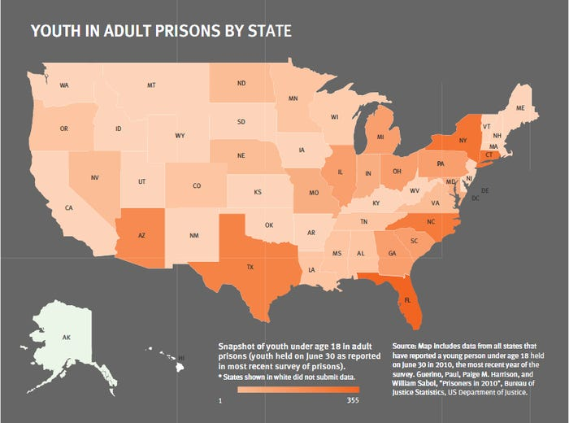
Figure 1

Appendix 2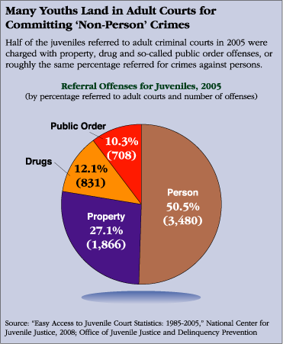
Figure 2

Appendix 3
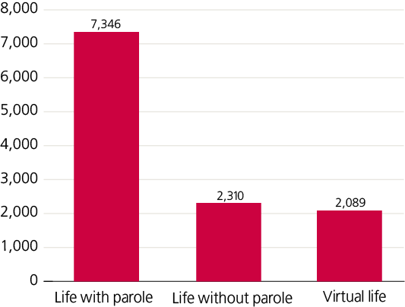
Figure 3

Appendix 4
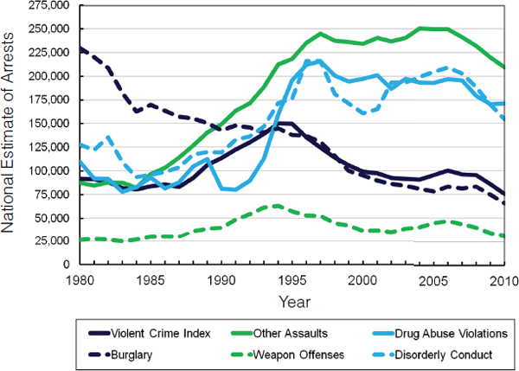
Figure 4

Appendix 5
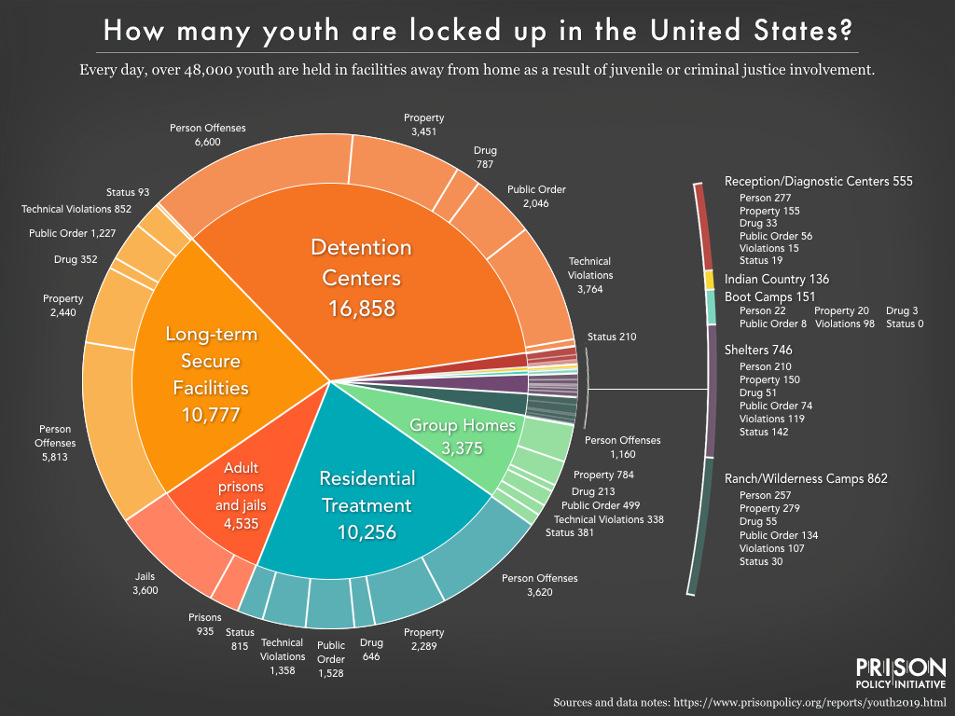
Figure 5

Appendix 6
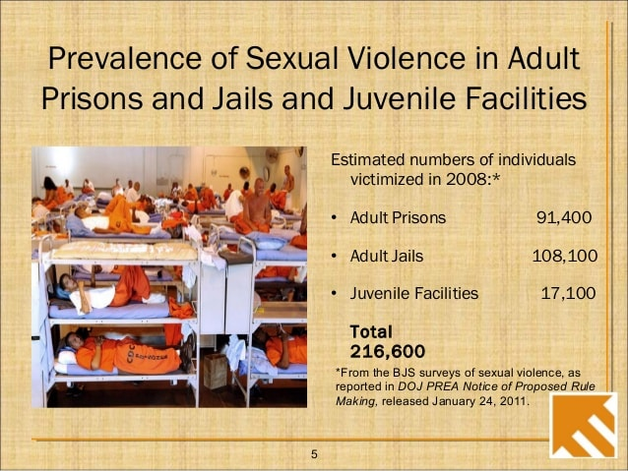
Figure 6

